DOG
MENU

DOGGY TAPAS
Doggy Kisses Treats
Doggy Sausages
Bark Burgers
Peanut Popcorn
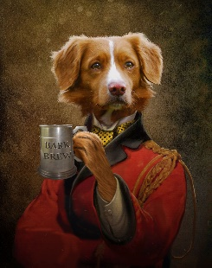
DINNER FOR ONE
Full, Complete Meals - made from Natural Ingredients (Grain-Free)
Chicken Roast Dinner
Drumstick, sausage, peas & carrots – on a bed of premium food.
Fish & Chips
Sprats, sweet potato fries & peas– on a bed of premium food.
DOGGY BEER
Bark Brew

Products are GRAIN-FREE
and made from NATURAL INGREDIENTS
(except for doggy beer, which contains malted grain extract)
Your opinion matters! Email us at feedback@sirwoofchesters.com

